- Reference letter

- Project summary
Project Title: Acoustic Monitoring for Migratory Birds in Lithuania – Land of the Storks
Principal Investigator: Yi-Chin (Sunny) Tseng, University of Northern British Columbia, Canada
Local Partners: Tomas Pikūnas (Žuvintas Biosphere Reserve), Modestas Bružas (Curonian Spit National Park)
Current Support: National Geographic Early Career Grant (EC-KOR-53792R-18)
Funding Requested: Pairi Daiza Foundation Grant for Biodiversity and Conservation Research

The project aims to establish Lithuania’s first long-term passive acoustic monitoring program for migratory birds, providing baseline biodiversity data across key habitats. Initial pilot recordings were collected during the 2025 breeding season, demonstrating strong potential for large-scale implementation. With support from the Pairi Daiza Foundation, we will continue and expand monitoring during the 2026 breeding season at two ecologically significant sites—Žuvintas Biosphere Reserve and Curonian Spit National Park—with full collaboration from local partners.
Fieldwork will occur from May to July 2026, preceded by logistical planning and equipment preparation, and followed by data analysis and reporting by December 2026. The project will deliver a comprehensive baseline dataset of avian acoustic activity to support long-term biodiversity monitoring and conservation management in Lithuania.

Pictures of me in both Zuvintas and Curonian, and the map of both sites

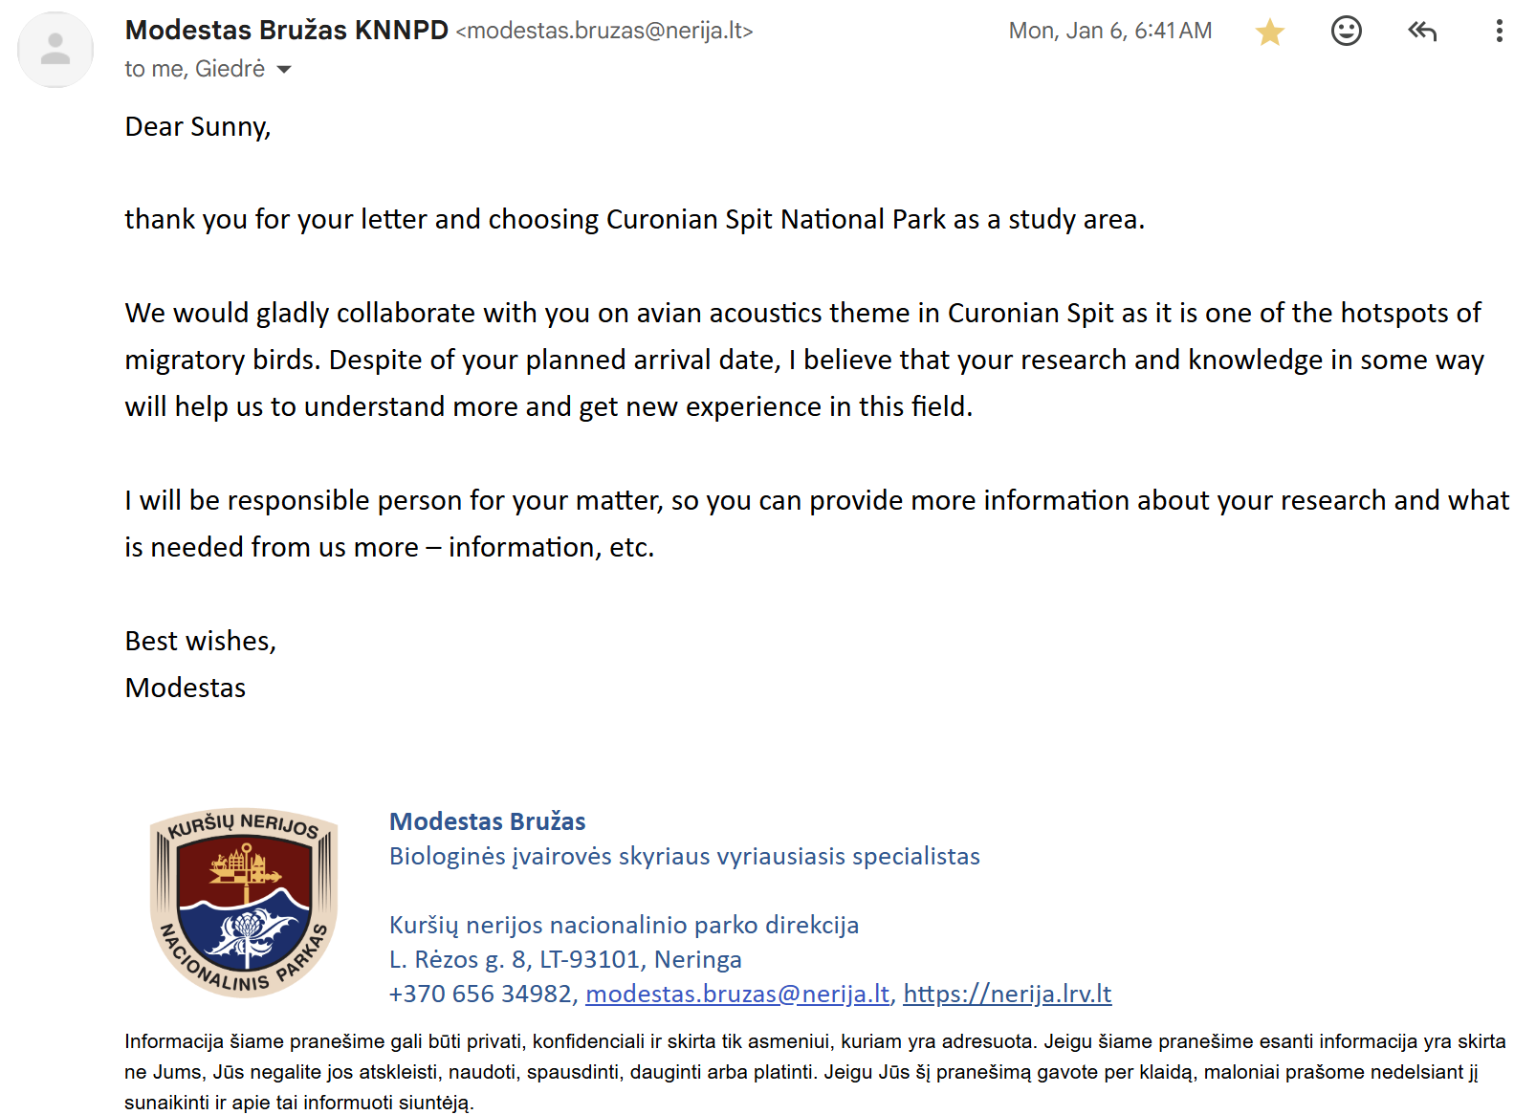

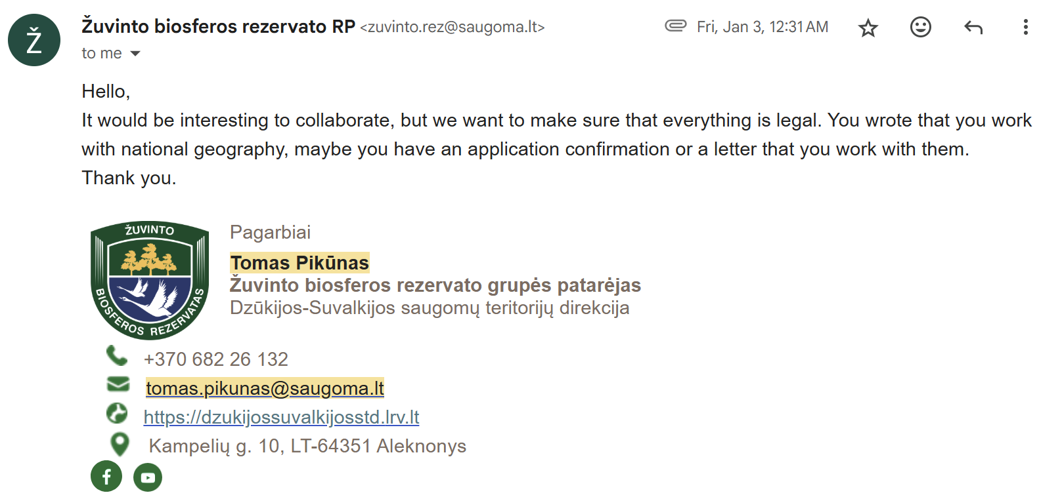
- Project details (1000 words)
- Scientific context and general objective

Lithuania, characterized by over 3,000 lakes, extensive mixed forests, and a rich network of wetlands, supports one of Northern Europe’s most diverse avian communities. The country lies along the Baltic Flyway, a key migratory route that connects breeding and wintering grounds across Europe, Africa, and Asia. Its diverse landscapes—ranging from the dunes of the Curonian Spit to the wetlands of Žuvintas Biosphere Reserve—provide crucial stopover and breeding habitats for hundreds of migratory and resident bird species.

Despite this ecological importance, systematic biodiversity monitoring through soundscapes or passive acoustic methods has not yet been established in Lithuania. Existing bird sound documentation is fragmented, with only a few local recordings and limited publicly accessible archives. Long-term acoustic monitoring offers a powerful, non-invasive way to capture species presence, vocal activity, and temporal changes, providing a permanent record of avian biodiversity.
The general objective of this project is to establish Lithuania’s first passive acoustic monitoring program for migratory birds, creating a long-term baseline dataset to inform biodiversity conservation and management. This project directly contributes to the Pairi Daiza Foundation’s mission by expanding scientific knowledge, protecting natural habitats through informed management, and fostering public awareness of avian diversity.

- Description of the grant project
  - Specific objectives
Deploy autonomous recording units (ARUs) in two key protected areas—Žuvintas Biosphere Reserve and Curonian Spit National Park—to document avian biodiversity during the 2026 breeding season.

Collect and process both soundscape recordings (community-level data) and species-specific vocalizations (individual species documentation).

Contribute processed data to open-access biodiversity platforms, such as the Xeno-Canto sound library and the Global Soundscape Project, to enhance global accessibility and conservation value.

Provide Lithuanian partners with data summaries and recommendations for integrating acoustic monitoring into long-term biodiversity monitoring frameworks.

  - Study areas
Curonian Spit National Park is located between the Baltic Sea and the Curonian Lagoon. This UNESCO World Heritage Site features diverse habitats—coastal dunes, forests, and wetlands—and holds the highest recorded diversity of bird species in Lithuania. It also neighbors Ventės Ragas Ornithological Station, a key site for migratory bird research.

Žuvintas Biosphere Reserve, in southern Lithuania, is the country’s largest wetland complex and a UNESCO Biosphere Reserve. It serves as a breeding and staging area for more than 240 bird species, including several globally threatened taxa such as the Aquatic Warbler (Acrocephalus paludicola) and Great Snipe (Gallinago media).
Picture of the site map with hexagon for both sites.

  - Data processing and analysis
Audio recordings will be processed using BirdNET, a machine-learning algorithm that automatically identifies bird species from sound. The results will yield site-specific species lists, vocal activity indices, and temporal patterns. Cleaned recordings of individual species will be manually verified and shared on Xeno-Canto, expanding Lithuania’s representation in this global repository.

  - Work plan

- Provisional budget

- Ethical aspect dealing with sample collection or use
This project is fully non-invasive and poses no risk to birds or their habitats. Acoustic monitoring is conducted passively using autonomous recorders placed along established trails or research zones with prior permission from park authorities. No handling, trapping, or disturbance of wildlife will occur.

- A paragraph dealing with the outreach and communication aspect
  - Pairi Daiza Foundation will be potentially involved in the outreach of the granted project for science education TV broadcast and social media

  - Taiwan ambassador in Lithuania

  - Local community sharing for the story for the second visit
A picture of me with the Taiwan ambassador

- A short CV (2 pages max)

